**Title: Test Cases for the Social Media App (Facebook)**

**Facebook App Login:**

**Step 1:**

To check whether the Facebook Login is valid or not

and considering it as the first test case.

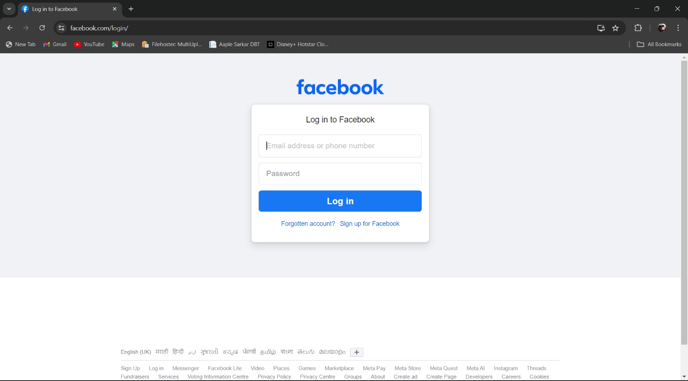

Default Login Page

Checking the Validation of Login page:

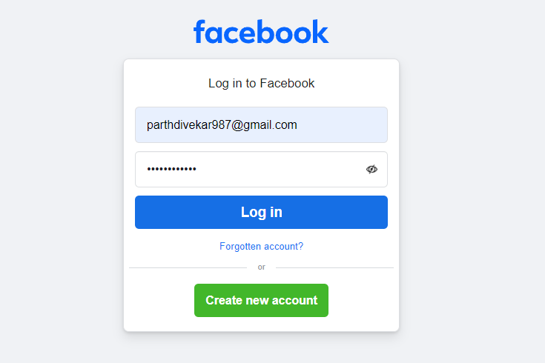

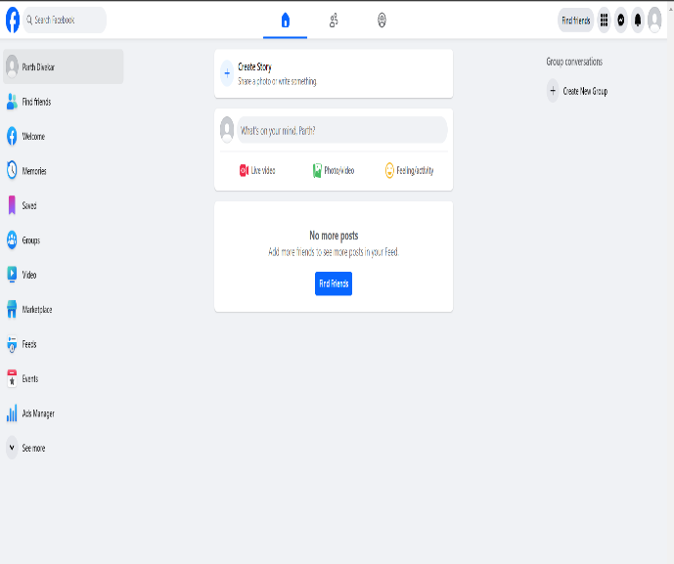

After the Successful Login

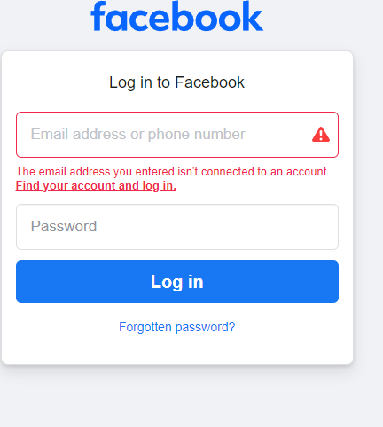**Expected Outcome:** User Logged in Successfully.

**Login failed due to Invalid Credentials.**

**Status: fail.**